11/2/16 Assembly

Class Notes

gpio readall

* Raspberry terminal command
* Shows the slot info for breadboard
  + Volts
  + Input/output

When pinning breadboard

* Careful not to reroute power back to pi, since it receives 3v while breadboard sends 5v

Breadboard

* Colors
  + Red – pin 21
  + Green – pin 22
  + Blue – pin 23
  + For other colors, adjust intensity of lighting
    - High green + high blue = yellow
* You can control the pins through the command line
* R0
  + Pin number
  + Input/output
* R1
* R2

Arrays

* Address = base_address + index*size of data element
  + Increments through array
* Ad = ba + index* sz;
  + Ex) 32 bit = ad = ba + 4*index;
    - 4*index == LSL #2
* Visualzation:
  + Stack: 132,860
  + a[0] - 132,860
  + a[1] - 132,864
  + a[2] - 132, 868
  + a[3] - 132, 872
* Creating Arrays

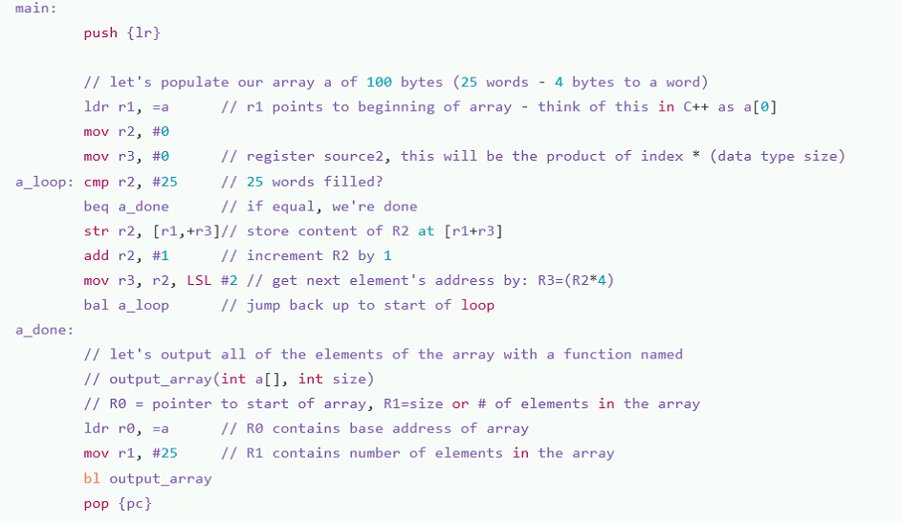

* R1 – content of array
* R2 – index
* Offset
  + Required to read through stack
  + Ex) str r2, [r1,+r2, LSL #2]

Ex2)

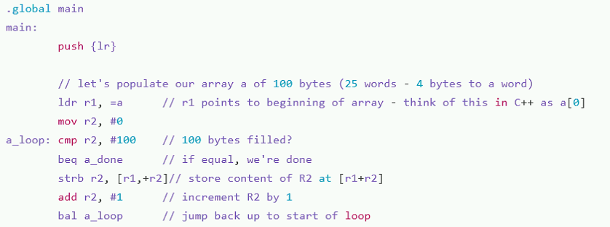

* This example is different since we don’t shift bytes
* strb
  + Def.) Store Byte
  + Array is stored in a single byte